**IDEATION PREPARED BY TEAM: 3 Geeks. *This Document is designed to**

**be opened in Microsoft Word**



**PROBLEM STATEMENT:**

**Waste Sorting:**

Design a smart waste collection system to help segregation of waste efficiently. The system should allow the citizens to sort the different types of solid waste they want to dispose of and the authorities to collect it in the sorted manner. It should have 2 interfaces-for the Citizen and for the Collector.

Categories of waste-

1. Organic Waste (kitchen waste, garden waste, flowers, leaves etc)
2. Recyclable Waste (plastic, paper, cans, glass etc)
3. Electronic Waste (batteries, bulbs, electronic appliances etc)

**APPROACH TOWARDS SOLVING THE PROBLEM:**

**TITLE OF THE PROJECT: “ ∅** **WASTE”**

1. **PREFACE:**

Accumulation of waste has several environmental impacts, leading up to serious problems, if left unaddressed. Needless to say, the most important reason for proper waste management is to protect the environment and for the health and safety of the population. It is a very important topic that needs to be addressed, and everyone should be aware why waste segregation can be the key to the survival of life and put an end to the worsening effects in the natural biological system. With the passage of time, cities are becoming ‘smart’, but the current waste sorting and disposal system is not. Proper segregation of waste, and the disposal of the respective kinds of wastes in their corresponding feasible ways is really the next step we need to take to make the environment cleaner, safer and a better place to be in.

1. **THE INTENDED PROTOYPE:**

Our project aims at managing the complete process of collection, sorting, recycling and disposal of waste (subject to its type) in a unique and innovative manner alongside a rewarding system to attract the masses. The prototype, on a broad scale, can be divided into **four** parts:

1. A user-friendly **website** will be the primary interface for the citizens to let the authorities know about the types of wastes they would want to dispose of. It would also serve as a tool for the authorities to enable them to take required actions for arranging the collection and disposal methods as per the requirement. The user (the citizen) will have an account in the website through which he/she can book a slot as per a pre-defined time table for the collection of waste, the details of which will be maintained in a database. He/she will have the option of choosing the type of waste that has to be collected, the estimated amount of waste as per the reading shown in the smart bins (discussed in point 3 below), and enter further details of the contents such as paper, vegetable peels, empty cans, batteries, etc. from our catalogue. If the user finds that there is some or the other product which is not present in the catalogue, then he/she can create a category of their own and/or provide necessary details of the items they want to dump.
2. Setting up of a **factory** for the purpose of assessing, assimilating, segregating and providing recycled products out of suitable wastes.
3. Introducing the use of **‘smart’ technology** for collection, transportation and assessing the worth of valuable materials that have been extracted from electronic waste. Items include:
4. **‘Smart’ Bins:** These bins will be provided with sensors to assess the amount of waste that has been dumped in it and alert the citizen that it is time to get the waste disposed of, when the amount of waste has reached a certain level. This would ensure unnecessary overflow of waste in the house. These bins will also be fitted with ‘weight sensors’ to estimate the weight of waste that has to be disposed of---much of a handy tool for the collecting authorities.
5. **GPS enabled vehicle tracking:** The garbage collecting vehicles will be GPS module enabled. This will enable vehicle tracking using a web-mapping platform such as Google Maps. A very efficient way to track status of a collecting vehicle, update the same in the cloud servers and arrange for reserves if problem arises with a particular vehicle.
6. **Two Arduino Modules** one of which will be attached inside the pickup trucks for assisting the collector/technician in assessing the value of certain useful materials such as gold, copper, etc that have been extracted from electronic waste and the other inside a factory unit/module. It will have sensors to detect the weight of the material and will give an estimate of its value by chalking out its cost per unit weight from a real-time database in our cloud servers.
7. A **Credit provision** system for the customers in order to encourage the citizens to dispose of their wastes daily. They will be provided with virtual ‘credit points’ in return for the wastes they dispose of. These credit points after getting accumulated to a certain value, can be exchanged for Gift Cards of verified e-commerce facilities such as those of Amazon, Flipkart, etc. This will certainly be a win-win situation, satisfying both parties, and convincing the citizens to use our system, as well as promoting a cleaner and greener environment in the long run.
8. **THE COMPLETE PROCESS SUMMED UP:**

* **Scheduling Slots for Waste Collection:**

For **organic waste** collection, each registered user will be automatically subscribed. Organic wastes will be collected on a daily basis, and collection need not be scheduled exclusively by the user.

The available time slots for **recyclable** and **E-wastes** will be displayed on our website. For Recyclable wastes, customers shall book a slot for waste collection only after the smart bin gives an alert. (If the collector finds that the weight of waste is below the minimal waste required for collection, credits might be deducted from user’s account as compensation). They have to choose the sub-categories of wastes for collection from our database, for example paper, plastic, glass, metal cans, knobs, utensils etc. If the item is not listed, the customer can request for a new category.

For **E-wastes** a pickup of the item can be scheduled by booking a pickup request where customers will have to upload a picture of their item along with its category, brand and model which will further be assessed by a technician for a proper pickup service.

If the customers are not sure whether their waste falls under **organic**, **recyclable** or **e-waste**, they can search it up in our website. If it is not listed, they can leave a message typing the name of the waste and they shall be assisted in less than 24 hours by customer care executives.

* **Sorting, collection and disposal of waste:**

1. **Organic waste:** The collector would note the reading of the bin, upload it on the website, and collect the organic waste. Based on the weight of waste, the customer would be credited points. Being biodegradable, they will be disposed of in landfills and incinerators, while suitable wastes will be composted.
2. **Recyclable waste:** The collector would note the reading of the bin. The items would

be checked by an engineer with the help of a waste segregating device, and based on the type of waste, credits would be given by the engineer. After collection, such items will be cleaned and reprocessed into recycled materials as per their current condition.

1. **Electronic-waste:** The E-waste would be collected by the collector and brought to the factory. It will be thoroughly analysed, segregated and processed in factory modules by a special team and credits would be awarded based on condition and valuation of metals or refurbished parts extracted.

* 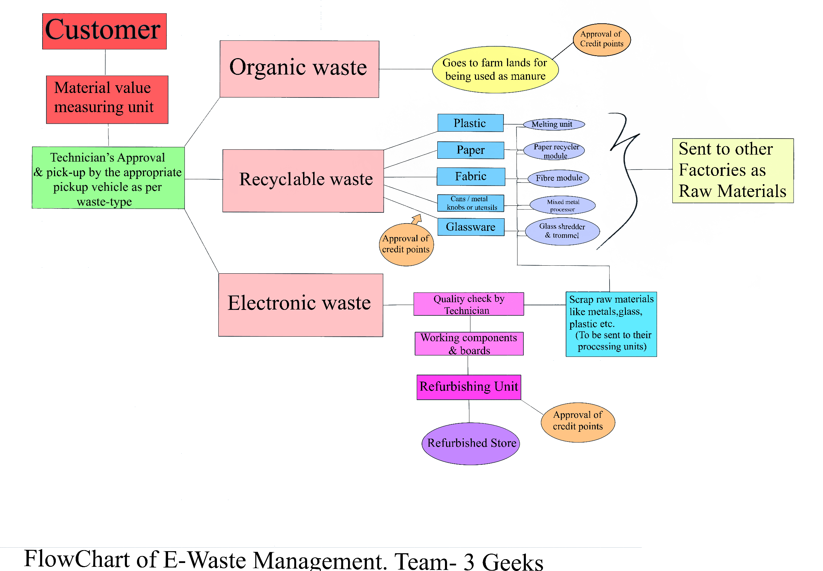 **A Flowchart for better visual representation:**